ANNEX II + III: TECHNICAL SPECIFICATIONS + TECHNICAL OFFER

Contract title: Supply of Equipment p 1 /…

Publication reference: 05-397/2

Columns 1-2 should be completed by the contracting authority
Columns 3-4 should be completed by the tenderer
Column 5 is reserved for the evaluation committee
Annex III - the contractor's technical offer
The tenderers are requested to complete the template on the next pages:
- Column 2 is completed by the contracting authority shows the required specifications (not to be modified by the tenderer),
- Column 3 is to be filled in by the tenderer and must detail what is offered (for example the words ‘compliant’ or ‘yes’ are not sufficient)
- Column 4 allows the tenderer to make comments onits proposed supply and to make eventual references to the documentation
The eventual documentation supplied should clearly indicate (highlight, mark) the models offered and the options included, if any, so that the evaluators can see the exact configuration. Offers that do not permit to identify precisely the models and the specifications may be rejected by the evaluation committee.
The offer must be clear enough to allow the evaluators to make an easy comparison between the requested specifications and the offeredspecifications.

LOT 1: Supply of Equipment for Daily center Unit for the elderly
1.  Item number | 2.  Specificationsrequired | 3.  Specificationsoffered | 4.  Notes, remarks,  ref to documentation | 5.  Evaluation committee’s notes
1. | Active Passive trainer  Pre-set programs feature basic modes (active, passive, assisted, symmetry), as well as a selection of common pathologies including Parkinson’s disease, multiple sclerosis, cardio etc.Active Passive Trainer combines both PASSIVE and ACTIVE training by using physical effort in conjunction with the electrical operation of the motor.  Technical specification /Dimensions of the device:  Height: 102 to 122cm  Length: 87 to 92cm  Width: 68cm  Weight: 36kg  Maximum user weight: 135kg.  Rotation speed (bars and legs): 5 to 60 revolutions per minute in passive trainingfrom 5 to 90 revolutions per minute in active training.  Distance between footrests: 13.5 to 25.5cm (measured on the inner sides)  Distance between arm handles: 20cm (measured on the inner sides).  Leg trainer: 50 to 125mm.  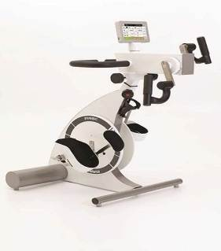Type and electrical class: type BF Class II A device.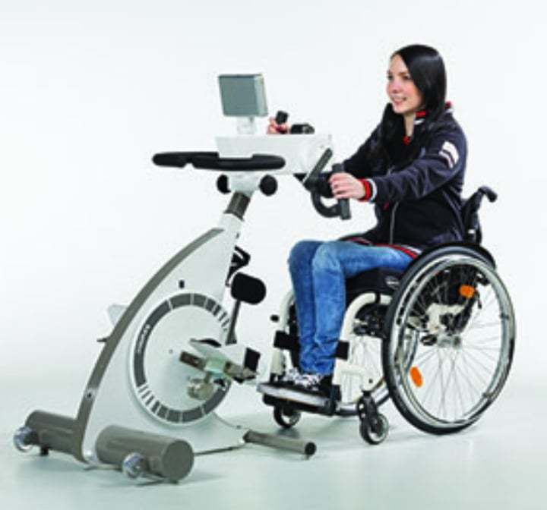  The attached images are for informational purposes only.
2. | LIFTER UPRIGHT AKCES MED  LIFTER Upright (standing frame).  Technical Specifications  - Joystick  - Occupational tray that also helps as a support.  - Ergonomic non-slip handles.  - Knee support with height and width configuration.  - Silent actuator that lifts the user to an upright position.  - 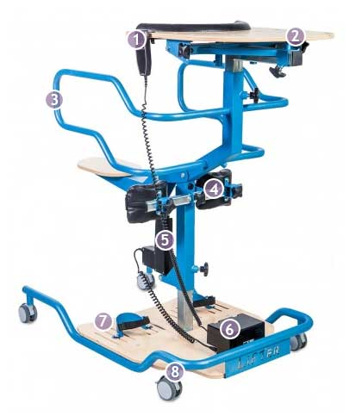Battery and control board.  - Base with adjustable foot straps.  - Wheels with brakes +Accessories:  Transport belt  Chest support  The attached image is for informational purposes only.  Lifter Specifications
  Measurements:
  W | Indicative user height (cm) | 120 – 200
  C | Table height (from base) (cm) | 97 – 124
  H | Knee support height (cm) | 24 – 60
  G | Knee pad width (cm) | 21 – 41
  I | Seat height from the ground (cm) | 36
  L | Seat length (cm) | 50 – 60
   | Maximum user weight (kg) | 120
   | Width (cm) | 66
   | Length (cm) | 105
   | Height (cm) | 110
3. | Cable Crossover Machine Home Gym, Wall Mount Cable Station with 200LBS Weight Stack,Lat Pull Down Machine with 27 Positions Dual Pulley System  Dimension:  - Material: 12-gauge Steel  - Overall Height: 80.71 -in  - Overall Width: 27.95 -in  - Overall Depth: 28.35-in  - Weight Capacity: 200 lbs  - Cable System Ratio: 1:2  - Number of Package: 4  - 1x Cable Crossover Machine  - 2x Cable handle  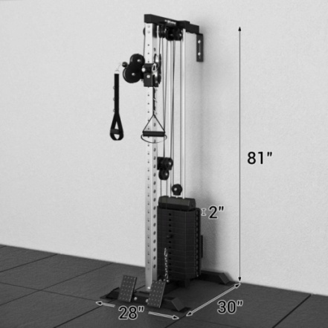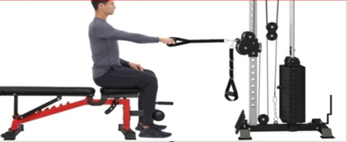  The attached images are for informational purposes only
4. | Weight Bench  The Weight Bench with minimum 9 back pad angles (0, 10, 20, 30, 45, 60, 70, 80, 90 degrees), 5 seat pad angles (-30, 0, 5, 10, 15 degrees) and 3 leg attachment positions.  Stable Support：Triangular support structure and 40*80mm heavy-duty thickened steel tubes, holds minimum 800 lbs weight. Foam leg-hold attachment and 4 mm-thickened ladder-style sheet of back.  Texture： The weight bench should be made of PU Leather  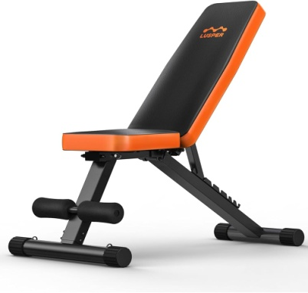  The attached image is for informational purposes only.
5. | Oxycycle III - Passive/Active Exerciser  Exerciser for rehabilitation and strengthening of arms and legs.  Description  With adjustable speed.  Multi-function display with a dial that can measure time, RPM level and calories burned, as well as a 15-minute timer and a safety stop button if a cramp or muscle spasm occurs.  Motor power: min: 80 W.  Dimensions: 50 cm x 46 cm x 38cm or similar ( dimension +-10%)  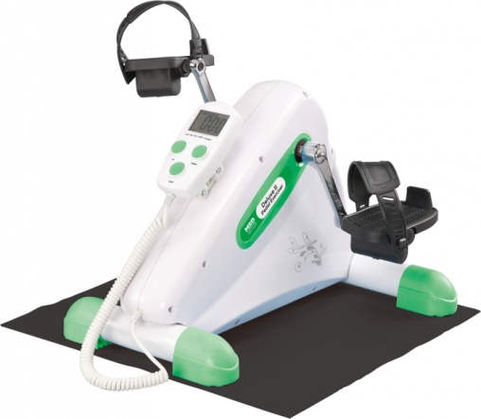  The attached image is for informational purposes only.
6. | Electric Treadmill  maximum speed of at least 18 km/h. Bluetooth calculator with minimum 5 LED display and at least 36 training programs (to shows all important training parameters such as speed, time, distance traveled, heart rate). The bar to be intended for users with a maximum weight of up to 120 kg.  - Engine power: min 2.5 HP  - Maximum speed: at least 18 km/h  - Slope Range: 1-15%  - Maximum allowed load: 120kg  - Dimensions of the mat: 142 x 50 cm or similar (with dimension +- 10%)  - Dimensions of assembled device: 171.1 x 81.5 x 138.7 cm or similar ( with dimension +- 10%)  - Device weight: up to 90 kg  - Computer indicators at least : time, speed, distance traveled, heart rate  - At least 36 exercise programs  - Control the speed and angle of the tape through the hand grips  - Heart rate measurement through hand sensors  - 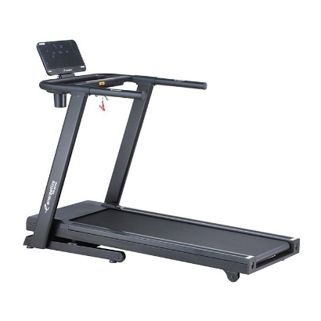Built-in MP3 speaker  Attached image is for informational purposes only
7 | Multifunctional exercise equipment (Energetics MG 10 1.0 BLACK/BLUE or similar)  At least Three levels of tilt angles, adjusted mechanically.  Opportunity to increase or decrease the speed in steps of 0.1 km per hour (buttons), so there is no need to stop driving to change the dynamics of the load.  Option for increasing of running speed 2 km per hour (using the buttons)  At least 12 programs, (start the distance countdown, set the required amount of energy consumption, as well as the time for which you plan to run a certain distance et.).  All indicators should be displayed on the front console of the simulator, touch sensors on the handles monitor the heart rate.  Technical specification:  - Maximum weight up to 100kg  - Mechanical adjustment of the backrest of the walking belt  - Heart rate sensors  - 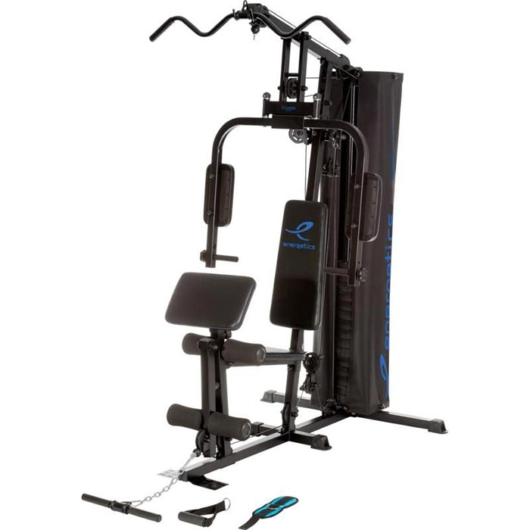Computer indicator: exercise time, calories burned, distance covered, heart rate, speed.  - Maximum speed: up to 12km  - Engine power: min. 1.25 kW  - Additional information  - Product color: black  - Warranty: 12 months  Dimensions and weight:  - Length: around 137cm ( +-10%)  - Width: around 69 cm ( +-10%)  - Height: around 157cm ( +-10%)  - Weight: around 45 kg ( +-10%)  Attached image is for informational purposes only
8. | Therapeutic scales  Rehabilitation staircase with single flight 4 steps and anatomic handrails  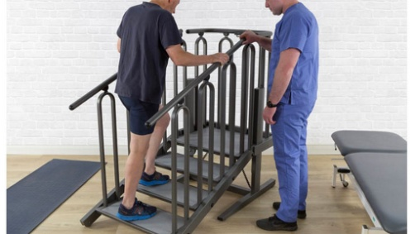  Attached image is for informational purposes only
  Handrails adjustment | 60-100 cm
  Step width | Min. 56 cm
  Step depth | Min. 30 cm
  Step height single flight | 12 - 15 cm
  Single handrail maximum load | Up to 135 kg
9. | Muscle stimulator  Wireless  Muscle intelligence: MI-scan, MI-autorange, MI-tens, MI-action  Web connection  Download objective  Upload remote history  Program categories: at least following: Conditioning, Fitness, Pain Management, Recovery / Massage, Rehabilitation  Number of programs: min 36  Number of channels: min.4  Screen: Matrix colors  Power: min. 120 mA, 400 us, 150 Hz  Energy: Rechargeable battery in less than 2h  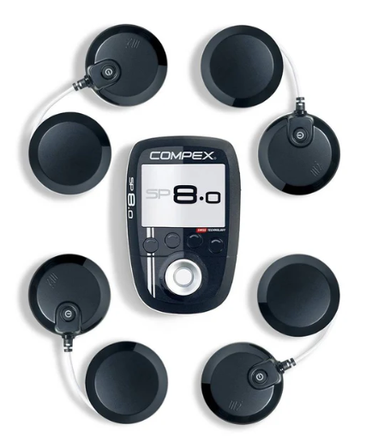  Attached image is for informational purposes only
10. | Active VIBRATING BALL  - Three stage vibration that can be adjusted depending on the massage area and purpose  - Auto power off function after 10 minutes  - Dual battery for quick charge  - Peanut shaped massage ball for optimized massage  Size: (cm) 17.5x9x9 (dimensions are approximate and may vary by +-10%)  · Weight: (kg): up to 0.8  · Material: silicone  Battery life min.3.5-5h  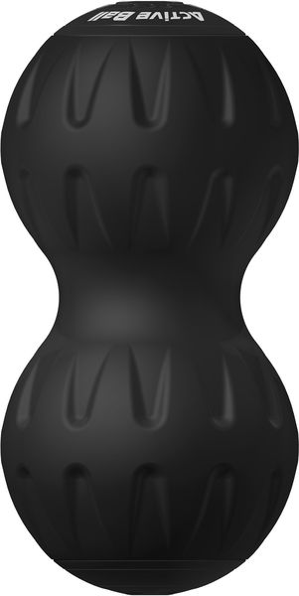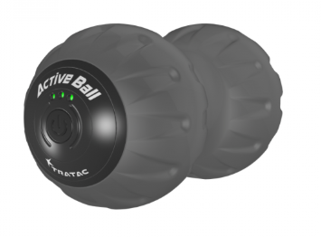  Attached imagesare for informational purposes only
11. | VIBRATING ROLLER  - 4 different vibrating options (1300 - 3700 RPM).  - Rechargeable lithium batteries (2200mAH/7.4Vdc).  - 10 minute auto-off.  - Material:EPP (eco-friendly).  - Size:15x45cm (dimensions are approximate and may vary by +-10%)  Product (cm): 44,5x15x15.  Product (kg):up to 0,9  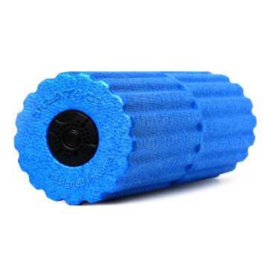  Attached image is for informational purposes only

LOT 2: Supply of Equipment for providing of ocupational terapy , art terapy and medical equipment for mobile units
1.  Item number | 2.  Specificationsrequired | 3.  Specificationsoffered | 4.  Notes, remarks,  ref to documentation | 5.  Evaluation committee’s notes
1. | First aid boxes  Set for first aid- includes:  Scissors, bandages, plasters, triangular scarf, gloves, cotton wool, PVC 2mx1.4m Cassette dressing instruments disposable dressing kit, basic medical instruments, knife, tweezers, clips,
2. | Device for measuring blood pressure  for daily blood pressure monitoring-digital device, should be Clinically verified device according to BHS standard A / A, which, in addition to simple operation, also should offers recognition of irregular pulse, 99 memories, pulse tone, time and date.
3. | Inhaler-intended for the medical use of drugs that are recommended for the treatment and calming of the respiratory organs and pathways for home use.  Should be equipped with a piston compressor with an air filter plug, which is changed periodically Reliable, resistant, free from lubrication, constructed in accordance with the European norms that are current regarding construction criteria, due to the reliability of the device during electro medical use (EN 60 601-1; EN 13544).should contain nebulization ampoule, nasal applicator, mouth applicator, mask for adults, mask for children, hose for air connection, filter.
4. | Quick Medical Thermometer(digital)for measuring body temperature
5. | Pulse oximeter-Pulse oximeter is a small device that measures the amount of oxygen present in people's blood. This is an indirect method of measuring the level of oxygen in the blood. The device is worn on the tip of the finger and uses light of special wavelengths to measure the oxygen Screen: TFT  Power mode: 2 x AAA 1.5V alkaline batteries  SpO2 measurement range: 70～99%  Pulse rate measurement range: 30～250rpm  Accuracy: ± 2 ％ (70% 99%), indeterminate (＜ 70%)  Dimension: 62 x 31 x 36mm  Weight: 45g (without batteries)saturation in the blood-
6. | CGMS Set of 6 Sensors with application device CT-202 + signal transmitterCGMS is a system for continuous measurement and monitoring of blood sugar levels  It should contain three components - a Sensor with application device CT-202with an application device, a transmitter /CGMS Signal Transmitter CT-100 and a receiver where the role of a receiver CGMS Data Receiver CT-100BD  The Continuous Glucose Monitoring System (CGMS) allows you to:  Information about the level of glucose in the blood at any time of the day  It informs about how and whether certain foods or medicines affect your blood sugar level;  the system will immediately report and alert if there is a deviation in the glucose level in order to quickly take appropriate measures;  Minimizing the risk of diabetes-related complications: problems with the eyes, blood vessels and the nervous system;  Minimizing risks during pregnancy and possible complications after the fetus;  Sensor with application device - the process of applying the sensor is quick and painless, waterproof
7 | Defibrillatorthe automatic (semi-automatic) Defibrillator which can be used by non-medical persons.for basic life support and the use of the automated external defibrillator is:  - Early recognition and calling for emergency medical help  - Early application of basic resuscitation measures (BLS), "buying time"  - Early defibrillation, reactivation of the heart  - Early application of extended resuscitation measuresSuitable for use by both adults and children.  - Acoustic and visual guidance.  - Memory of performed defibrillations.  - The device must be portable with a built-in battery for uninterrupted operation from min. 4 hours or min. 200 defibrillations or min. - -- Capacity of 4 Ah.  - Energy 200 - 300J, according to WHO standards.  - Easy to transport 2.3 kg.  - Possibility of automatic communication with emergency help.  - Possibility of detection in case of possible theft of the defibrillator itself.  - Computer port for data transfer.  - Safety standards such as IPH4 and IEC 61000.
8. | Anti-Decubitus Pillow - Means against decubitus, pillows  Dimension: at list 42x42 cm
9. | Anatomical bathroom chair made of plastic seat and stainless-steel legs that are adjustable in height.  At the ends of the seat there are openings that serve as handles for holding on while sitting, and the openings on the seat part serve for water drainage during bathing.  Height from the floor: 42 - 55 cm  Maximum patient weight: 225 kg
10. | Bag for medical equipment  - Bag with big opening and hinges  - With special hinges preventing accidental closing  - With 2 pockets in the front  - Incl. ampule holder  - Dimensions: L 43 x W 21 x H 27 cm( or similar dimension +-10%)
11. | Aspirator for secretionAspirator for nasal, oral and tracheal aspiration of bodily secretions (mucus) in adults and children. Should be intended for minor surgical interventions and for post-surgical home care. Should has an antibacterial and hydrophobic filter that does not allow liquids to pass through, thus protecting the patient and the device from cross-contamination.  Maximum aspiration pressure: 0.75bar  Secretion flow: 15lt/min in 0.75bar
12. | Medical Goose – Universal  It helped to fulfill the physiological need for bed  Universal – men and women  Simple and easy to use  With a cap  Capacity: 0.8 l  Color: white
13. | Set for physical (compression) therapy  The compression therapy system should provide high-quality lymphatic decongestion. It also helps improve blood and lymph circulation, prevents deep vein thrombosis and provides relief from swelling.  DIGITAL COMPRESSOR  Adjustable pressure (pressure range 20-250 mmHG)  6 programs are available  The set consists of: bag, digital compressor, connector, hand compression pad with 4 chambers and  4-chamber leg compression pad.
Art Therapy Supplies for Adults-Materials
14 | Wooden Standing Art Easel for adult  (штафелај)
15 | Canvases for painting -Art Canvas (Primed watercolor canvas on cardboard 50x50 cm
16 | Canvases for painting -Art Canvas (Primed watercolor canvas on cardboard 30x30 cm
17 | Canvases for painting -Art Canvas (Primed watercolor canvas on cardboard 50x50 cm
18 | Canvases for painting -Art Canvas (Primed watercolor canvas on cardboard 30x30 cm
19 | Set of acrylic paints 24 not less than 20ml each paint
20 | Large painting set Daler-Rowney Complete Artist Kit –minimum 122 pieces The package contains minimum: 48 x crayons, 24 x oil pastels, 10 x brushes for painting with acrylic and oil paints, 10 x 12 ml acrylic paint in a tube, 10 x sketching papers, 8 x mini painting canvases 7.5 x 7.5 cm, 2 x graphite pencils 4B, 2 x graphite pencils B, 2 x graphite pencils H, 1 x graphite pencil 2B, 1 x graphite pencil 6B, 1 x plastic painting palette (6 paint slots), 1 x sharpener, 1 x eraser, 1 x palette knife, 1 x metal case
21 | Adult Coloring Book  Minimum 30 coloring pages, A4 format
22 | Felt-tip pens (different colors) min 12 pieces in package
23 | Wooden crayons – pack of minimum 12 colors
24 | Tempera Paint Sticks - Set of 12 pieces (different colors) in package
25 | Paint Paper Pad (18 Sheets X6 colors total 20 packages) ( colored paper pad A4, A3)
26 | WhiteA4 copy paper 500 sheets
27 | Blunt Tip Scissors
28 | Blank Flipbooks – min 200 sheets
29 | Paint Brush Variety Set
30 | Fabric Paper – set 30 sheets minimum 6 colors
31 | School Glue , pencil - minimum 15 gr.
32 | Durable Artist's Smock
33 | Collage materials set – min. 1000 pieces per set
34 | Modeling materials  Plaything clay set – Box min. 12 colors
35 | Sand for sensory exercises – min 1kg per box
36 | Aprons
37 | Table mats – 50x 30 cm ( or similar dimension +- 10%) plastic
38 | Boxes 100 cm x100 cm ( cardboard)
39 | Folders A4
40 | Maxi creative set for making crepe paper flowers  Maxi creative set for making crepe paper Package contents: crepe paper, strings, polystyrene beads, glue, ink, sponge, paint Theme: crepe paper bouquet of flowers and bright flowers Number of flowers up to 30: green, pastel green, white Use: paper flower production, interior decorations, trend creation Complexity: medium Packaging: 1 set
41 | ART Cloudy Clay min. 250 gr,
42 | 22-piece sketching set  Complete drawing kit for artists (including MultiPastelChalk Pencils, Charcoal Pencils,Sketch & Wash Pencil, Layout Pencil, Drawing Pencil, Carbon Sketch, Draughting Pencil, Kneaded Eraser and 2-Hole Metal Sharpener)
43 | art set in a metal box  tight closing case  case size 37.5x29 cm( or similar dimension +-10%)  contains: minimum - crayons, markers, oil pastels, watercolor paints and other accessories minimum139 pieces
Occupational Therapy Supplies for Adults-Materials
44 | Memory Cards for play board game (big)
45 | Passels (with 50 pieces big)
46 | Passels (with 100 pieces big)
47 | Play Cards regular/uno packages
48 | Analog Clocks (Big)
49 | Pastel (big packages)  Soft Pastels Box Set Of min 24 colors  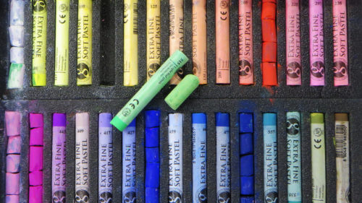
50 | Therapeutic clay – 500 gr.
51 | Anti stress balls - 70mm
52 | Plastic clips set – min 100 pieces
53 | Wooden pegs min 30 pieces set
54 | buttons, organizers set min. 150 pieces different colors
55 | Wooden Beads + laces sets – min. 50 pieces
56 | Soft Balls – minimum 12 Pieces 2.4 Inch Soft Foam Balls Lightweight
57 | Elastic bands for light exercises
58 | Hoop – 45 cm
59 | Training Cones set – min. 20 pieces
60 | balance pillow
  Material: | Permanently high flexible PVC
  Diameter: | 30- 34 cm
  Height: | 5- 7 cm
  Maximum payload: | Up to 150 kg
61 | hand massagers  min 5 massage modes and intensity levels  Built-in rechargeable battery
62 | therapeutic blanket 150cm x 200cm
63 | spoons forks with thick handles sets
64 | towels for folding 70x120cm
65 | Domino set
66 | spill-proof cups
67 | board game Bingo Set Lander
68 | Plastic flower pots 7l
69 | organic fertilizer bag 10 l
70 | glue gun PLASTIC GUN ∅11MM, 65W, EXTOL CRAFT
71 | Glue sticks for hot glue gun 250 x 7 mm - set of 10 pairs
72 | Colored paper A4 neon colors 75 gr. 1/50
73 | Hammer Fabriano Elle Erre 200gr, 50x70cm
74 | Office set staplers,decorative pins,magnets,Eraser,sharpener,notebooks,pencils. The entire set (min. 500 pieces) is packed in a transparent plastic box.
75 | Hammer color 50 x 70 250g.  • 250g paper  • Dimension: 50 x 70cm different colors 4
76 | Scissors
77 | Plastic organizer 65l., 64x45x32cm
78 | Stretchy exercise bands
79 | Pilates ball 56 CM

LOT 3: Supply of medical equipment for vulnerable groups
1.  Item number | 2.  Specificationsrequired | 3.  Specificationsoffered | 4.  Notes, remarks,  ref to documentation | 5.  Evaluation committee’s notes
1. | Electric lift for transporting patients with motor impairments and mobility problems.  Load capacity up to 150 kg  .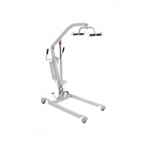  Attached image is for informational purposes only
2. | Electric medical bed  with three functions– the possibility of electric lifting of the back and head part, the part at the knees and feet and electric height adjustment.  The sides at the head and legs should be made of ABS plastic  Base on which the mattress is placed should be made of steel construction, which emphasizes the adaptability of the mattress and enables the absorption and cushioning of the body's weight.  Folding side rails should be mounted on the bed, and wheels should be mounted for easier movement and positioning of the bed.  An infusion stand and a urinary catheter holder should be also mounted on the bed.  Outer width of bed: 100 cm  External length of bed: 211 cm  Inner width of bed: 90 cm  Inner length of bed: 200cm  Maximum load capacity: 250 kg  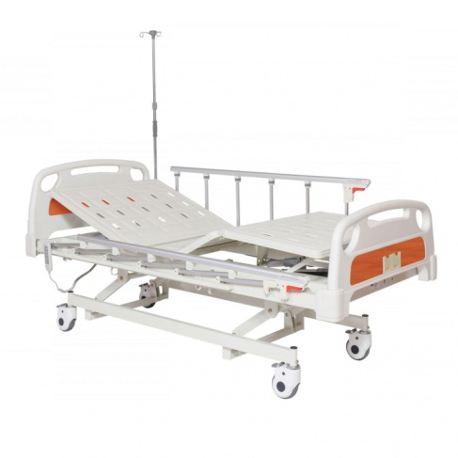Attached image is for informational purposes only
3. | Mattress  three sections mattress for a medical bed3-piece mattress for a medical bed. Density 25D  Made of memory foam with a zippered cover.  The dimensions should match the bed that will be offered in the previous position (LOT 3 item number 2)  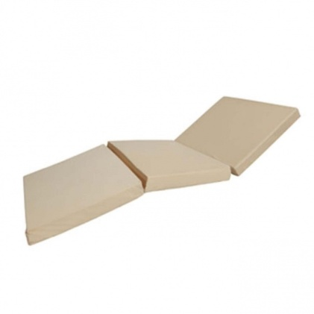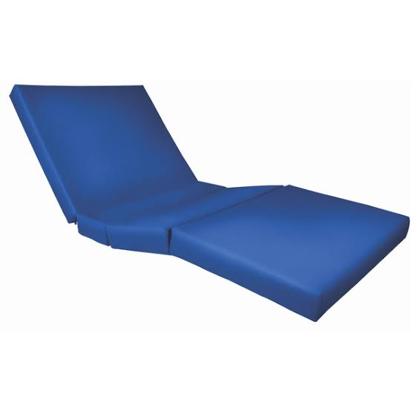  Attached images are for informational purposes only
4. | Oxygen concentrator 5l  - Flow Rate1 - 5 Liters Per Minute Continuous Flow  - Power Consumption  300 Watts  - 24 hours work continuously  - Four alarm systems: low oxygen concentration alarm, power off alarm, pressure circulation fault alarm and compressor fault alarm  - AVG oxygen purity: 93%±3%  - Low sound level: less than 45dB (A)  .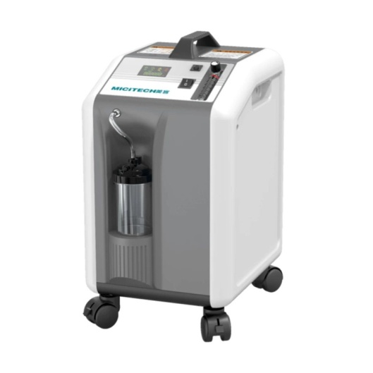  Attached image is for informational purposes only
5. | Universal wheel chair with movable backrest and adjustable shoes - standard and adaptation for WCDescription  Construction: Chromed metal frame  Assembly: Yes  Pages: Movable  Slippers: Height adjustable  Seat width: 44 cm  Total width: 64 cm  Seat height from the ground: 53 cm  Cart weight: 25.6 kg  Maximum user weight: 100 kg  Front wheels: 20 cm  Rear wheels: 58 cm  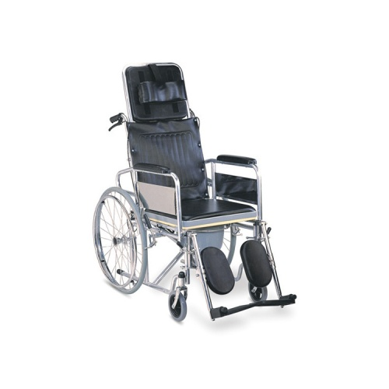  Attached image is for informational purposes only
6. | All-Terrain Electric Wheelchair (Robooter X40 or similar)  SPECIFICATIONS  Durable mileage: about 25 km  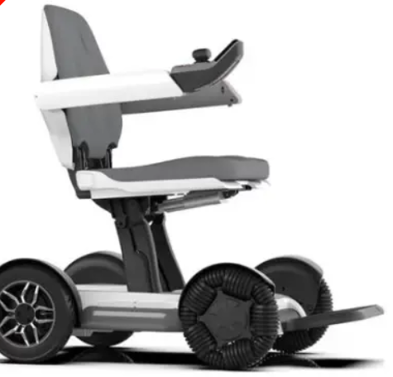Maximum speed: min. 5 km/h  Maximum obstacle height: min5 cm  Trench width: min. 10 cm  Climbing angle: at least 10°  Net chassis height: 7 cm  Minimum radius of rotation: 76 cm  Seat height: 57.5 cm  Seat width: 42 cm  Seat depth: 42 cm  Pillow: 42 x 42 cm  Stroller size: 100.5 x 59 x 93 cm  Folding size of the stroller: 82 x 59 x 37 cm  Body net weight: up to 45 kg  Charging time: 4-6 hours  Front tire: 10 inch off-road wheel  Rear tire: 10 inch pneumatic tire  Side arms: adjustable angle  Maximum load: 120 kg  Battery: Triple Lithium Battery (20AH, ,10AH)  Waterproof grade: IPX4  Attached image is for informational purposes only
7 | Rollator –  Load capacity up to 110 kg  Brakes on the handles  Compact construction  Height: 83-93 cm  Remote weight: up to 6 kg  Maximum user weight: 110 kg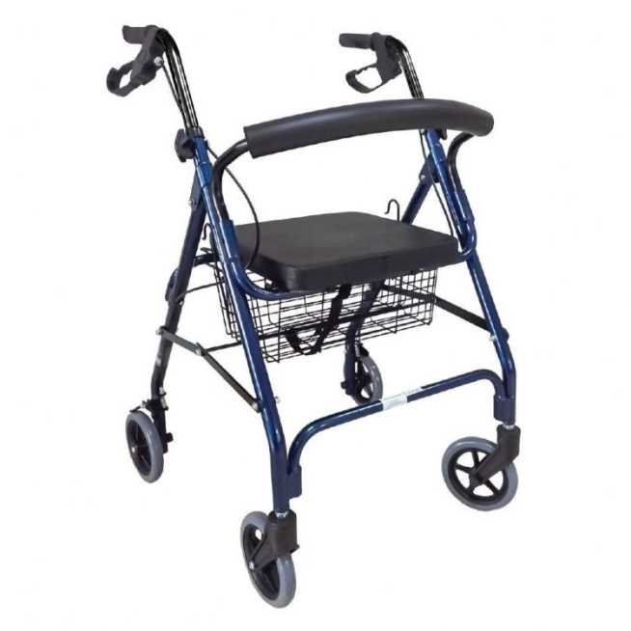  Attached image is for informational purposes only
8. | Electric lifting toilet chair with wheels  Solid 2.0mm steel frame  Easily adjustable seat height for personalized comfort  Front wheels with brakes and rear universal wheels for smooth movement and stability  User-friendly height adjustment mechanism for effortless adjustment  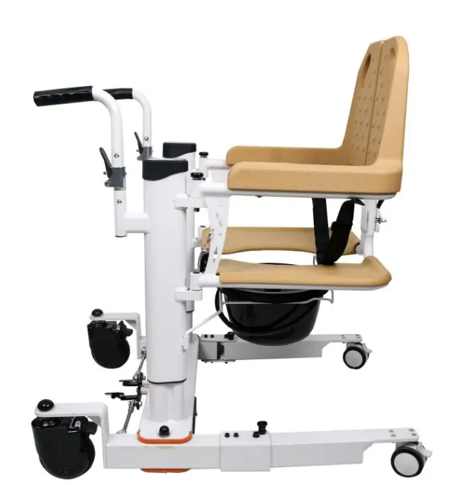Push handle designed for caregiver assistance  Fixed armrest  Fixed footrest  Adjustable hydraulic seat height  Product specifications  Total length: 81 cm  Total width: 59 cm  Seat width: 48 cm  Rear wheel diameter: 12.5 cm  Front wheel diameter: 7.5 cm  Seat height: 40.5-56 cm  Total height: 83-98.5 cm  Backrest height: 34 cm  Maximum load: 100 kg  Net weight: 27.6 kg  Gross weight: 29.6 kg  Attached image is for informational purposes only
9. | Bath chair  Height adjustable  With a non-slip rubber foot pad  Product specifications  - Seat dimensions: 46x43 cm  - Total length: 54 cm  - Height: 42-54.7 cm  - Backrest height: 36 cm  - Maximum load: 120 kg
10. | Toilet seat  A chair that can be used as an independent toilet bowl by placing a plastic bowl, and without the plastic bowl, it can also be placed over an existing toilet bowl in the toilet.  Frame: aluminum with the possibility of adjusting the height of the legs, and the seat,  Cover and container: plastic.  SPECIFICATIONS  - Width: 54 cm  - Seat width: 45 cm  - Seat height: 45-55 cm  - Weight up to: 100 kg

