 | EUROPEAN COMMISSION  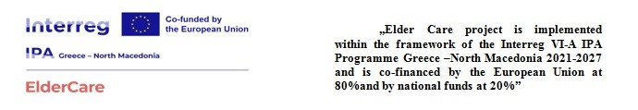
SUPPLY CONTRACT
Financed by Commission financing decision n° [insert number(s) of the
Commission Financing Decision(s) e.g. COM 2018/476]
Nº 05-397/2
financed from the general budget of the Union
MAIN CONDITIONS
Municipality of Negotino
str. Aco Adzi Ilov no.2, Negotino, (‘the contracting authority’),]
represented for the purposes of the signature of this contract by the authorised representative indicated in the respective field under “SIGNATURES” below
of the one part, and
[Option 1: The tender was submitted by a single tenderer or by a group of economic operators witha separate legal personality:
2. [Contractor’s full official name]
Legal form: [Contractor’s official legal form]
Registration number: [Contractor’s statutory registration number or ID or passport number]
Official address: [Contractor’s full official address]
VAT: [OPTION for contractors with VAT: VAT registration number]
(‘the contractor’)
[Option 2: The tender was submitted by a group of economic operators without a separate legal personality(de facto consortium/joint tender):
2. [[Include the name of the group if any -] group of economic operators who submitted a joint tender (‘the group’) [composed of the following members who are jointly and severally liable vis-a-vis the contracting authority for the implementation ofthis contract]
Legal form: [Contractor’s official legal form]
Registration number: [Contractor’s statutory registration number or ID or passport number]
Official address: [Contractor’s full official address]
VAT: [OPTION for contractors with VAT: VAT registration number]
appointed as leader of the group by the members of the group that submitted the joint tender,
[repeat the above data as many times as there are contractors in case of consortium/joint tender and continue numbering]
(collectively "the contractor"),
represented for the purposes of signing this contract by the authorised representative indicated in the respective field under “SIGNATURES” below,
on the other part,
HAVE AGREED as follows:
1. Subject matter
The title of this contract is: “TD 02 – Supply of Equipment.”
The terms and conditions applying to this contract are laid down hereafter and in the special and general conditions and their annexes. They shall be deemed to form and be read and construed as an integral part of this contractin the order described in the special conditions.
2. Contract value
The maximum amount covering all purchases under this contractis EUR[insert amount (insert amount in words)].]
3 Entry into force and duration
This contract enters into force on the date on which the last party signs it.
The maximum duration of this contract is 08monthsfrom the date this contract enters into force.
4. Bank account
Payments shall be made in accordance with the special conditions into the following bank account:
Name of bank: [insert bank name]
Exact denomination of account holder: [full name of account holder]
Bank account number: [insert bank account number].
For the contractor |  | For the contracting authority
Signatures

